Website of AutoLap-dataset

This is a static website built on github.io for applying the AutoLap-dataset. It contains the information of three different tasks and datasets. Serval tools are used in the development stage including GitHub, Firebase, Gmail, Nicepage, and Formspree.
Workflow
The website is held on https://autolap-dataset.github.io/. The website shows three tasks which includes Workflow Recognition, Laparoscope Motion Prediction and Instrument and Key Anatomy Segmentation. For the people who want to get the dataset, they can fill in the request form in the Download and Reference section. In the request form, requester need to provide the Name, Email address and Institution. They also need to choose the dataset includes LHD-T1, LHD-T2, LHD-T3 and LHD-Full. Before submitting the form, requester need to agree that the dataset they get will only be used for academic research and not for commercial usage. Then a box will pop out and requester can click ‘OK’ to download the dataset.
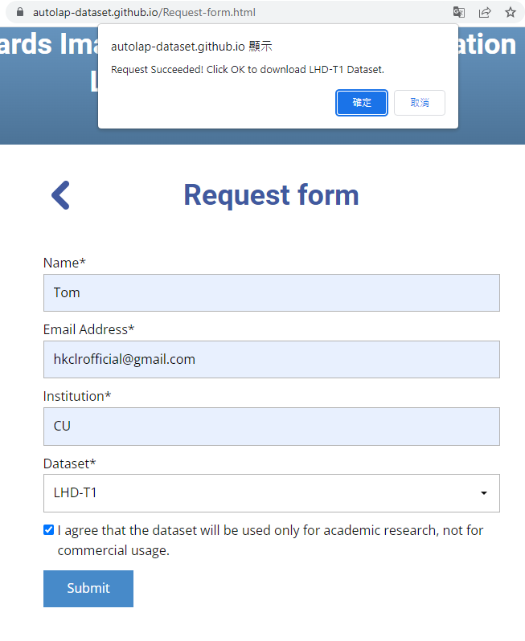
Fig. 1 Request form layout
After the request is sent, the form information will be sent to the Formspree and Formspree will send a notification email to the official Gmail account. The information will also be sent to the Firebase to record the requester information.
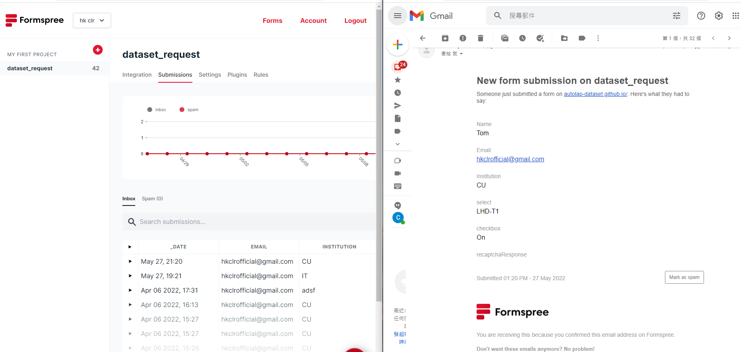
Fig. 2 Formspree and notification email

Tools
The tools that are used on the website are GitHub, Firebase, Gmail, Nicepage, and Formspree. The following table shows the login information.
Google account (access Gmail, Firebase and Nicepage) (remark: the password includes space)
Email address | hkclrofficial@gmail.com
Password | this is an official account
GitHub (remark: the password includes space)
Email address | hkclrofficial@gmail.com
Password | this is an official account
Formspree
Email address | hkclrofficial@gmail.com
Password | this is an official account
Table 1 account information

Firebase structure: [link: https://console.firebase.google.com/u/1/project/website-record/firestore/data/~2Fvisit-ip-record~2FhsEPzHg0xSF1Xjr5JwLi ]
- website-record
  - Dataset
    - Link
      - LHD-Full: [download link]
      - LHD-T1: [download link]
      - LHD-T2: [download link]
      - LHD-T3: [download link]
  - download_register
    - [email address of requester]
      - [requested dataset]
        - [each request has one file]
          - Dataset:
          - Date:
          - Email:
          - IP:
          - Institution:
          - Name:
          - Time:
  - visit-history
    - [visit date]
      - [visitors ip address]
  - visit-ip-record
    - [the test file used in development]

All account used in the tools are free account. The following are some main features of the free account of the tools.
Gmail [link: https://one.google.com/about/plans?hl=zh_HK ]
Storage | 15 GB
Firebase [link: https://firebase.google.com/pricing?authuser=1&hl=zh ]
Authentication | 10k/month
Storage data | 1 GiB
Network egress | 10 GiB/month
Document writes | 20K writes/day
Document reads | 50K reads /day
Document deletes | 20K deletes /day
Formspree [link: https://formspree.io/plans ]
Number of forms | Infinite
Projects | Infinite
Submissions | 50/month
Submission Archive | 30 Days
Linked Emails | 2
Nicepage [link: https://nicepage.com/premium ]
Number of Sites | 1 Site, 5 Pages
Table 2 plan information

